TAAKULO NGO
SRH Project: 2024 Annual Report
Project title: | Saving Lives, Fostering Resilience Providing lifesaving and integrated Sexual and Reproductive Health and Gender Based Violence services in humanitarian settings in Africa
Reporting Period | Oct to Dec 2024
Project Target: | 6,825
Project Location: | Bosasso and Las’anod
Project Fund code | KRA79
Total Fund Received | Total fund: : $ Fund utilized: 100% of fund
IP Name | TAAKULO NGO

Background:

Somalia faces a complex and multi-layered humanitarian crisis, exacerbated by protracted conflict, severe climate change impacts, displacement, and widespread poverty. According to the 2024 Somalia Humanitarian Response Plan, approximately 6.9 million people require urgent humanitarian assistance. The most vulnerable groups, particularly women and girls, bear the brunt of these challenges, experiencing disproportionately high risks of sexual and gender-based violence (SGBV), limited access to essential sexual and reproductive health (SRH) services, and high maternal mortality rates. Additionally, adolescents and youth face compounding vulnerabilities, including lack of access to education, healthcare, and livelihoods, which remains critically underserved.
This crisis has created urgent demands for humanitarian assistance, and a coordinated, integrated response is necessary. The project "Providing Lifesaving and Integrated Sexual and Reproductive Health and Gender-Based Violence Services in Humanitarian Settings," launched through the collaboration of the Government of the Republic of Korea (KOICA), the United Nations Population Fund (UNFPA), and the Federal Government of Somalia, is designed to address these pressing needs. This initiative aligns with Somalia’s National Development Plan (2020-2024), the National Reproductive, Maternal, Newborn, Child, and Adolescent Health Strategy (2023–2027), and the Sustainable Development Goals (SDGs), specifically Goals 3 (Health), 5 (Gender Equality), and 16 (Peace and Justice).
Through this partnership, the project aims to integrate SRH services, GBV prevention and response mechanisms, and youth-focused interventions to provide critical support to Somalia’s crisis-affected populations. The partnership will target the most vulnerable groups, including women, girls, adolescents, and youth, ensuring equitable access to services and fostering resilience in the long term. The involvement of TAAKULO NGO as the key implementing partner for SRH and GBV services will ensure the effective delivery of these services, particularly in the Puntland region, where the need is greatest.

The primary goals of this initiative are to reduce preventable maternal deaths, address the unmet need for family planning, and combat gender-based violence through comprehensive service delivery. With an estimated reach of 540,000 individuals, the initiative will provide tailored services, including youth-friendly spaces, and enhance the capacity of frontline workers, such as midwives. By integrating these efforts within the humanitarian-development-peace nexus, the project aims to foster long-term resilience and promote equitable development in Somalia."

Project Goal:
The overarching goal of this project is to increase the availability and accessibility of quality, lifesaving, integrated SRH and GBV services in protracted crisis settings, focusing on the most vulnerable populations, including women, girls, adolescents, and youth.

Project Objectives:
Objective 1: Ensure consistent, efficient, and high-quality lifesaving SRH services, guided by the Minimum Initial Service Package (MISP), are accessible to women and girls in crisis-affected regions.
- Deliver essential SRH services, including family planning, maternal health, and post-abortion care.
- Provide training and capacity-building for healthcare providers, especially midwives, to improve service delivery.
- Ensure that services are tailored to the needs of women and girls, especially those who are pregnant, lactating, or survivors of sexual violence.
Objective 2: Implement comprehensive and inclusive GBV prevention, risk mitigation, and response programs, ensuring safe, dignified, and quality services for all, with a focus on survivors of conflict-related sexual violence.
- Establish and expand safe spaces for survivors of GBV.
- Develop and implement risk-reduction strategies, including awareness campaigns and community outreach, focusing on both prevention and response.
- Ensure access to GBV case management, psychosocial support, legal services, and medical care for survivors.
- Provide specialized training for frontline workers and community leaders in GBV prevention and response.
Objective 3: Strengthen SRH and GBV coordination mechanisms to support stakeholders in delivering specialized and integrated services.
- Facilitate regular coordination meetings with key humanitarian actors, including government ministries, NGOs, and local authorities, to ensure service delivery is integrated and comprehensive.
- Support the establishment and functioning of SRH and GBV technical working groups to guide program implementation and ensure alignment with national and international standards.
- Promote the integration of SRH and GBV services into broader humanitarian, health, and protection response frameworks.

Indicators  (Use respective indicators from the shared Excel sheet,  if you’re implementing two services, please make sure to report as separate) | Aggregate  (Achieved) | Disaggregated Number
 | Aggregate  (Achieved) | Female | Children (If applicable) | Male | Persons with disabilities | No.  of Refugees or IDPs
Objective 1: Ensure consistent, efficient, and high-quality lifesaving SRH services, guided by the Minimum Initial Service Package (MISP), are accessible to women and girls in crisis-affected regions.

# of institutional deliveries, (Bosasso and Las’ anod Hospitals | 1,232 | 1,232 | (Girls below 17)  13 | 0 | 0 | 67
# of Cesarean sections, (Bosasso and Las”anod Hospitals | 221 | 221 | (Girls below 17)  10 | 0 | 0 | 32
Total # of ANC Clients  (Bosasso and Las”anod Hospitals | 3,100 | 3,100 | (Girls below 17)  219 | 0 | 0 | 121
# of women and girls who received FP services, (Bosasso and Las”anod Hospitals) | 1,500 | 817 | 71 | 0 | 0 | 213
# of pregnancy complications managed  (Bosasso and Las’anod Hospitals) | 450 | 462 | (Girls below 17)  51 | 0 | 0 | 276
Objective 2 : Lifesaving GBV prevention, risk mitigation, and response programs are provided to women, girls, men, and boys in need in a safe, dignified, and quality manner, including for survivors of conflict-related sexual violence and guided by the Inter-agency Minimum Standards for GBV in Emergency Programming.

# of women and girls who received GBV related medical services | 15 | 23 | 5 | 0 | 0 | 6
# of women and girls who received Psychosocial Support & Psychological First Aid | 100 | 100 | 10 | 0 | 0 | 8
# of women and girls who benefited from SRH/GBV awareness sessions | 200 | 440 | 204 | 0 | 0 | 266
# of women and girls who benefited from WGSS life skill training | 90 | 83 | 39 |  |  | 52
Objective: 3 SRH and GBV coordination mechanisms strengthened to support stakeholders in delivering quality services that are specialized and integrated as appropriate, as part of the humanitarian response and linked to systems strengthening for sustainable results.

Number of coordination meetings conducted | 1 | 1
Achievements:
- Institutional Deliveries: A total of 1,232 deliveries were conducted in Bosasso and Las'anod hospitals during this period. The high influx of displaced households due to the Arigabo conflict significantly increased the demand for SRH services. Among these deliveries, 67 were from girls below 17, highlighting the critical need for maternal care for adolescent girls.
- Cesarean Sections: A total of 221 cesarean sections were performed, with 32 cases involving girls under 17. This intervention was crucial for pregnant women who arrived displaced, often with complex obstetric needs.
- Antenatal Care: 3,100 women accessed ANC services, with 121 of these clients being adolescent girls. Many of these pregnancies were among women displaced by the Arigabo conflict, who benefited from emergency maternal care.
- Family Planning: A total of 1,500 women and girls received FP services, of which 213 were adolescent girls. These services helped address the reproductive health needs of displaced women, promoting family planning choices in the face of instability.
- Management of Pregnancy Complications: A total of 462 pregnancy complications were managed, including 276 cases involving adolescent girls under 17, many of whom were displaced by the conflict. These services were provided to ensure the safety of mothers and babies amidst challenging circumstances.
- GBV-Related Medical Services: 23 women and girls accessed specialized medical services for GBV-related issues, including 6 adolescent girls who were survivors of conflict-related sexual violence. The displacement due to the Arigabo conflict contributed to a surge in GBV cases, requiring urgent medical intervention.
- Psychosocial Support & Psychological First Aid: 100 women and girls received psychosocial support services, including 8 adolescent girls, providing them with much-needed mental health and emotional assistance in the aftermath of the conflict.
- SRH/GBV Awareness Sessions: A total of 440 women and girls participated in SRH and GBV awareness sessions, with 266 adolescent girls receiving essential information on how to protect themselves from sexual violence and access available services.
- Women and Girls Safe Spaces (WGSS) Life Skill Training: 83 women and girls benefitted from life skills training, with 52 of them being adolescents, empowering them to better navigate the challenges posed by displacement and conflict.
- During the reporting period, one project coordination meeting was held to enhance collaboration among stakeholders and ensure that SRH and GBV services were effectively integrated into the humanitarian response framework. This meeting facilitated better coordination and communication among partners to address the increased demand for services due to the displacement crisis.
- The coordination mechanism also ensured that specialized, high-quality SRH and GBV services were delivered effectively, with an emphasis on supporting displaced women and girls in Bosasso and Las’anod.
In summary, the reporting period from October - December 2024 highlighted the significant impact of the Arigabo conflict, which led to a high influx of displaced households, particularly affecting Bosasso and Las'anod. Pregnant women among the displaced populations greatly benefited from the Comprehensive Emergency Obstetric and Newborn Care services provided in these two hospitals, receiving lifesaving care in a time of crisis. The coordination and integration of SRH and GBV services were strengthened, ensuring that displaced communities received the necessary support to address both their immediate and long-term needs

Lessons Learned
- Increased Preparedness for Emergency Displacement:
The influx of displaced populations due to the Arigabo conflict underscored the importance of preparing healthcare facilities for an immediate surge in demand. This included ensuring that Bosasso and Las'anod hospitals were equipped to handle not only routine deliveries but also a high volume of complex obstetric cases and Cesarean sections. Future responses should strengthen preparedness plans to accommodate a surge in both the maternal health and gender-based violence service needs of displaced populations.
- Community Engagement and Awareness:
The awareness sessions on SRH/GBV proved highly effective in empowering displaced women and girls, particularly those under 17. These sessions served as a valuable tool to enhance community understanding of available services and the importance of seeking help for sexual violence and pregnancy complications. A key lesson is that sustained community outreach should be prioritized, particularly targeting adolescent girls, to improve awareness and service uptake.
- Coordination Strengthens Service Delivery:
The project coordination meeting held during this period demonstrated the value of regular stakeholder coordination in a humanitarian context. By bringing together key actors, the meeting helped streamline service delivery and ensured a unified approach to addressing the needs of displaced populations. Coordination mechanisms are crucial for avoiding duplication and ensuring that resources are efficiently allocated.
- Adapting Services to Specific Needs of Displaced Populations:
The project highlighted the need for adaptation in the delivery of sexual and reproductive health and gender-based violence services for displaced populations. The unique challenges faced by displaced women and girls, such as trauma, limited access to basic services, and the risk of sexual violence, require context-specific programming. Tailoring services to meet the needs of these vulnerable groups was essential to improve both service uptake and outcomes.
- Strengthening the Integration of SRH and GBV Services:
The integration of SRH and GBV services was vital for providing comprehensive care to displaced women and girls. Survivors of conflict-related sexual violence were able to access both medical and psychosocial support, illustrating the need for integrated service delivery. In the future, the continued integration of these services will enhance the effectiveness of the humanitarian response.

Challenges
- Overwhelming Demand for Services:
The Arigabo conflict led to a sudden and high influx of displaced households, particularly in Bosasso and Las'anod, creating a massive demand for maternal health and GBV services. This sudden spike strained existing healthcare systems and resources, particularly the maternal health facilities, resulting in increased pressure on staff and equipment. The need for scalable healthcare services to manage unexpected surges in demand is a significant challenge that needs to be addressed in future responses.
- Limited Resources and Capacity:
Despite efforts to prepare for the influx, the limited resources in both the hospitals and community outreach programs hampered the ability to fully meet the increasing demand. For example, while CEmONC services were provided, the sheer volume of high-risk pregnancies among displaced women stretched the capacity of healthcare workers, requiring continuous support and training to handle emergencies efficiently.
- Insecurity and Restricted Access:
- Stigma and Cultural Barriers:
In some areas, cultural stigmas around sexual violence deterred women and girls from seeking the necessary support and care. The challenge of overcoming social taboos and ensuring dignity in service provision was significant, particularly for adolescent girls who may have faced additional pressure to avoid seeking help due to fear of social isolation or shame. Addressing these cultural and social barriers required community sensitization and engagement to build trust and encourage service utilization.
- Psychosocial Support Gaps:
Although psychosocial support services were provided, there were challenges in scaling up these services to meet the mental health needs of displaced populations. The trauma faced by women and girls, particularly survivors of sexual violence, required long-term support, and the capacity of local service providers to offer adequate psychosocial care was limited. The gap in resources for mental health services highlighted the need for expanded training and resource mobilization to meet the psychosocial demands of the displaced.

.

Visibility Summary Table

Success Story: Ifrah Said – A Life Saved through Compassionate Care
Ifrah Said, a 37-year-old mother of 11 children, was facing a life-threatening situation when she went into labor with her 12th child. Living in the Boqolka Buush IDP camp in Bosasso, Ifrah, who suffers from anemia, was struggling with complications during labor. Her situation was made even more dire as she had no money to seek proper medical care and was initially relying on an unqualified traditional birth attendant to assist with the delivery. However, after enduring three days of labor at home, Ifrah’s condition worsened, and she was rushed to Ayaan Maternity Hospital for emergency care.
Ayaan Hospital, supported by UNFPA through its implementing partner TAAKULO NGO and funded by the KOICA Project, was her only hope. Upon arrival, the hospital’s skilled medical team immediately assessed her critical condition and determined that a Cesarean section was required due to complications with her labor. In addition to the labor complications, her anemia further heightened the risks involved. Thankfully, Ifrah was administered a blood transfusion to help manage her anemia and stabilize her condition before the surgery.
The medical team acted swiftly and performed a successful Cesarean section, delivering a healthy baby boy and saving both Ifrah and her child’s lives. Ifrah felt immense relief, as she had been in pain and distress for three long days prior to her arrival at the hospital.
Beyond the delivery, Ifrah was also offered counselling on family planning as part of her comprehensive care. Recognizing the risks of future pregnancies, she chose to receive an IUD, ensuring a safer future for herself and her family. The hospital’s provision of family planning was a crucial step in reducing the chances of future high-risk pregnancies, especially considering Ifrah’s health condition.
Ifrah’s story highlights the critical importance of qualified medical care in emergency situations. Had she not made it to Ayaan Hospital, her outcome could have been far more tragic, especially considering her anemia and the initial reliance on an unqualified birth attendant. The intervention of UNFPA, TAAKULO NGO, and KOICA allowed Ifrah to receive the necessary emergency obstetric care, saving her life and that of her baby boy.
Ifrah is extremely grateful for the care she received at Ayaan Hospital. She expressed heartfelt thanks to the doctors, midwives, and hospital staff who not only saved her life but also ensured that she received compassionate, high-quality care throughout her stay.
“I was so scared that I might not make it, and I feared for the life of my baby,” Ifrah said. “But the doctors and nurses at Ayaan Hospital gave me hope. They saved my life and my baby’s life. I am so thankful for everything. I never thought I would get this kind of care, especially since I had no money. I feel blessed, and now I can plan my future and be a better mother to my children.”
Today, Ifrah is recovering well and feels a profound sense of gratitude for the life-saving assistance she received. With the support of family planning services, she now has a chance to plan her future in a safer and healthier way, ensuring a better life for her and her 12 children.

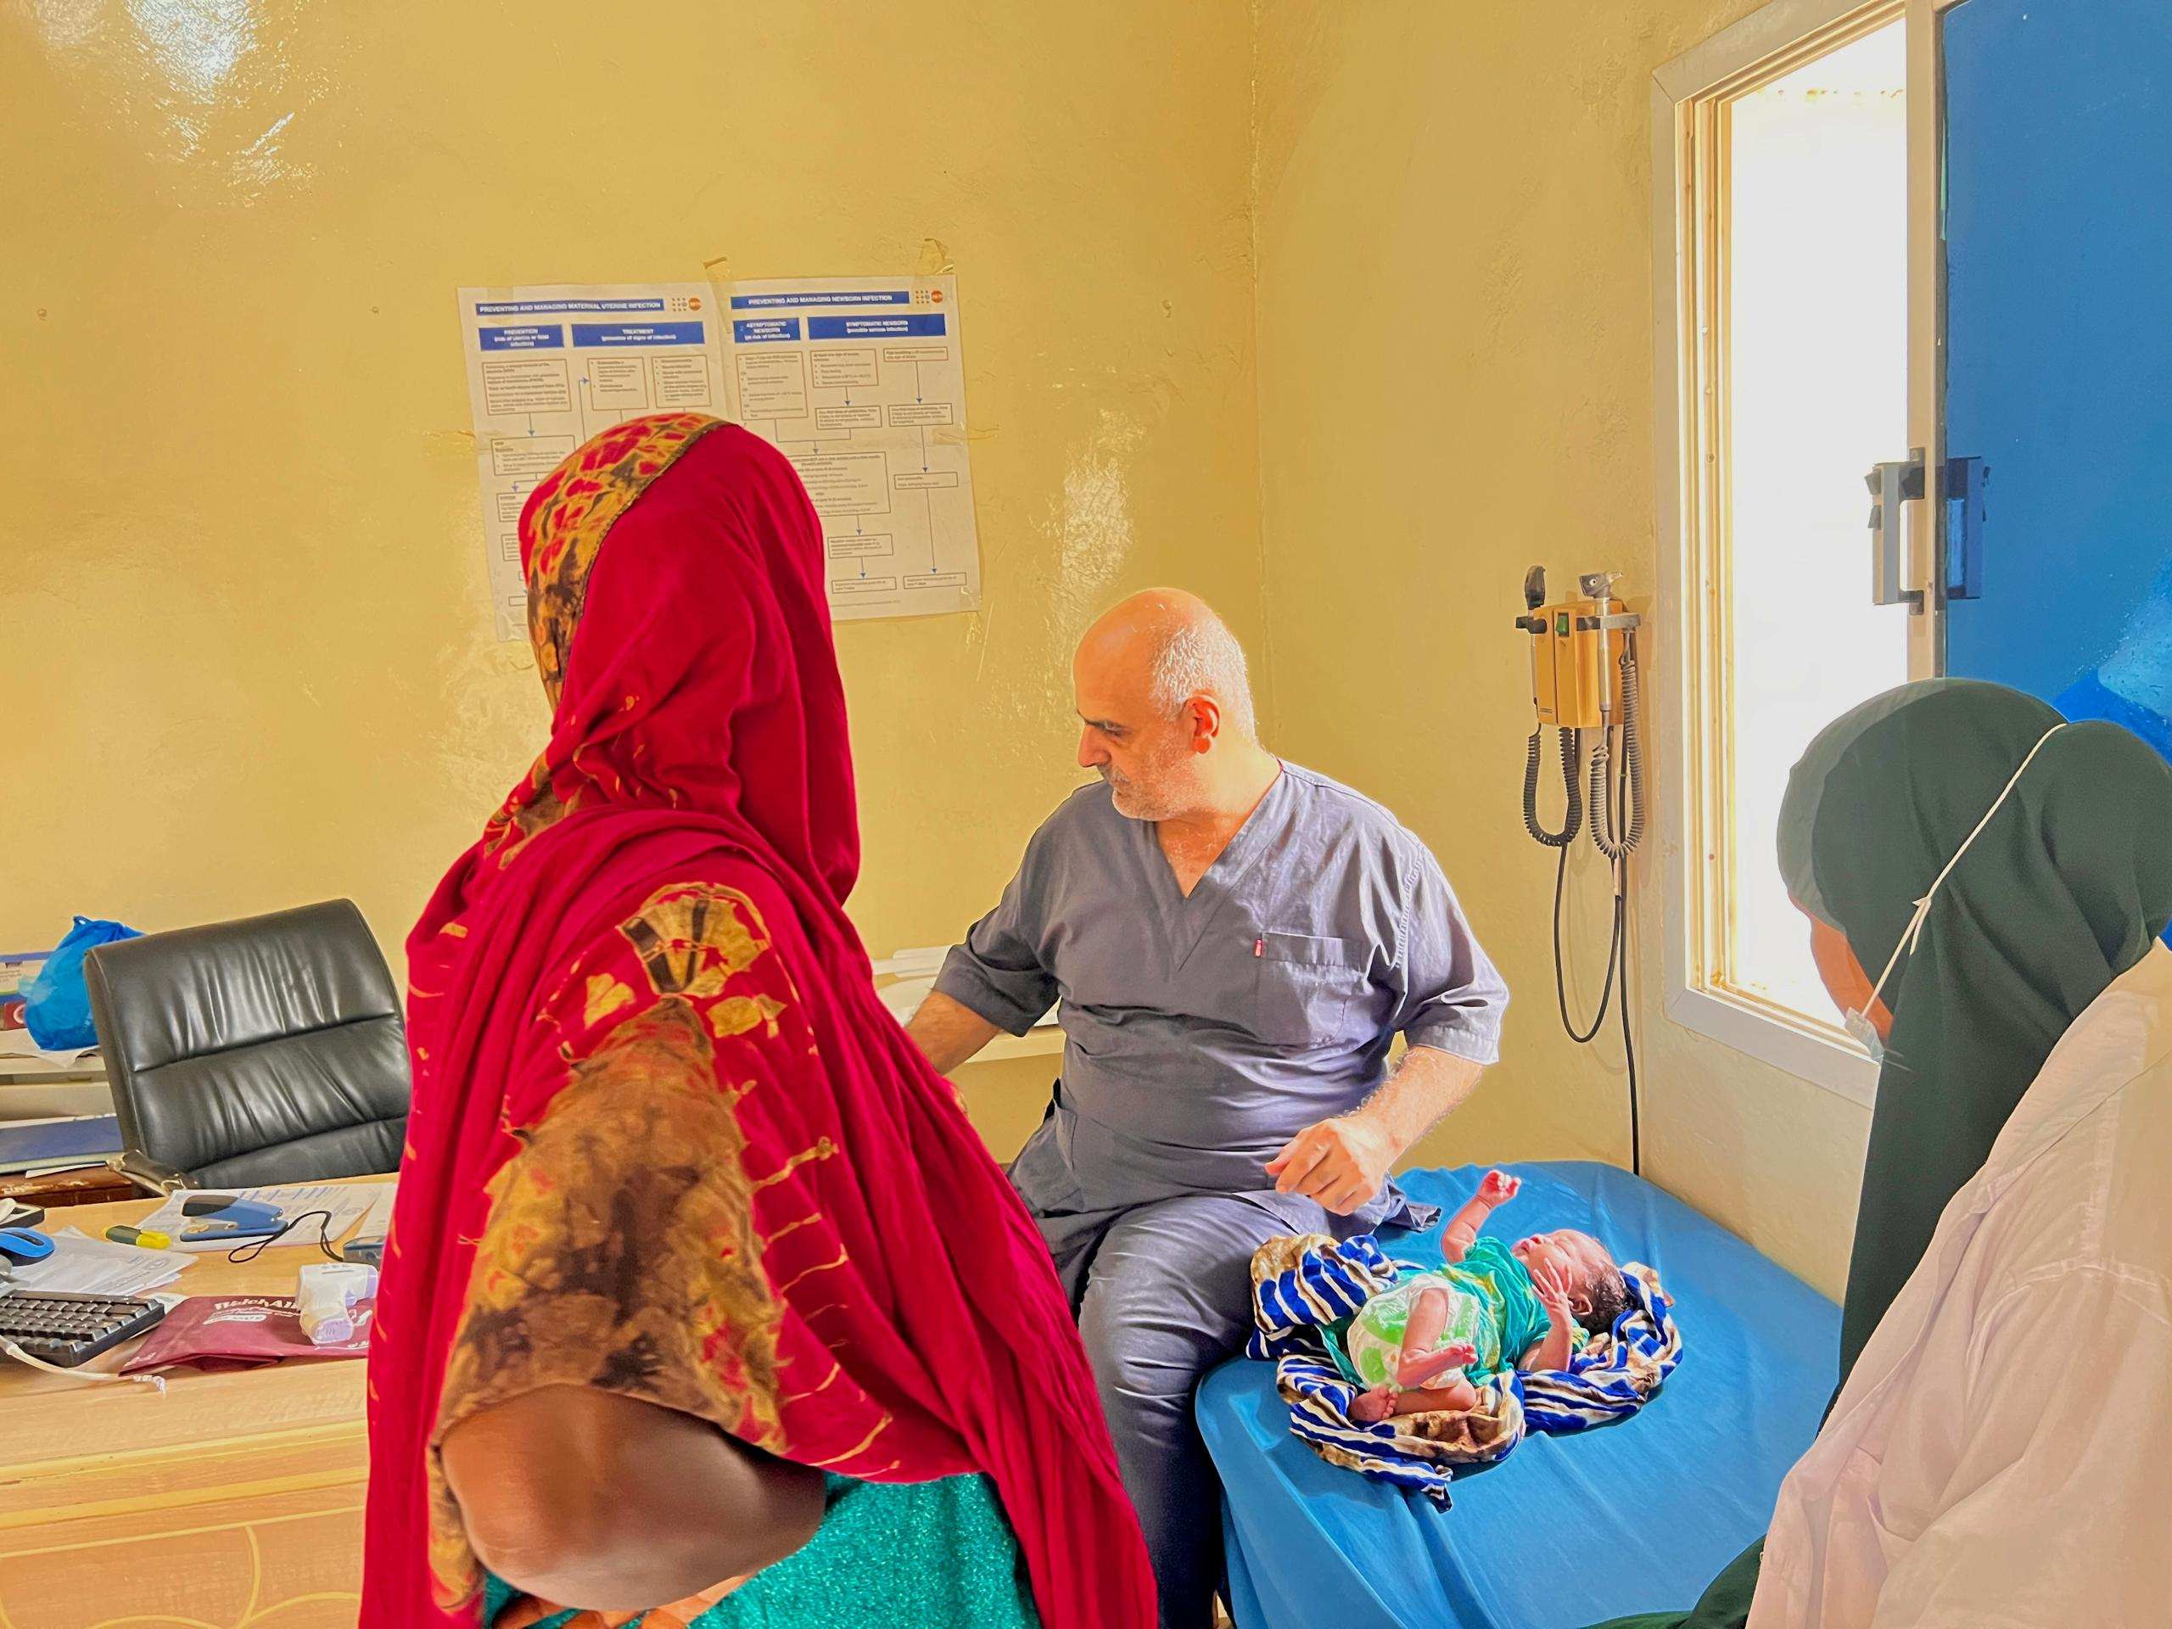

Success Story: 2 Nimo Hassan’s Journey to Motherhood
Nimo Hassan, an 18-year-old expectant mother, faced one of the most challenging periods of her life when conflict erupted in her hometown of Arigabo. Pregnant with her first child and yearning for safety, Nimo fled to a small village near Lasanod town. The village, though a haven from the violence, lacked a crucial necessity: a health facility.
As her pregnancy progressed, Nimo began experiencing severe symptoms of preeclampsia, a potentially life-threatening condition characterized by high blood pressure. Her health deteriorated rapidly, putting her and her unborn child at risk. Nimo’s family, alarmed by her worsening state, made the urgent decision to take her to Lasanod Regional Hospital.
Lasanod Regional Hospital, a beacon of hope for the community, is part of the KOICA project supported by UNFPA through its implementing partner, TAAKULO NGO, with generous funding from South Korea. The hospital is equipped with state-of-the-art facilities, life-saving supplies, and a dedicated team of healthcare professionals, including nurses, midwives, and doctors. These resources are vital for providing comprehensive sexual and reproductive health services to those in need.
Upon arrival, Nimo was promptly admitted and received immediate medical attention. The skilled medical team at the hospital worked tirelessly to stabilize her condition and ensure a safe delivery. Their expertise, coupled with the availability of advanced equipment and essential supplies, played a crucial role in managing her preeclampsia and preventing further complications.
After a few intense hours in the maternity ward, Nimo delivered a healthy baby girl. The joy and relief were palpable as the cries of the newborn echoed through the room. For Nimo, the moment marked the end of a harrowing journey and the beginning of a hopeful new chapter as a mother.
“I am so grateful to the staff at Lasanod Hospital and everyone who made this possible. They saved my life and the life of my baby,” Nimo shared with a smile, her daughter cradled in her arms.
Nimo’s story is a testament to the importance of accessible, high-quality healthcare services, especially in regions affected by conflict. The KOICA-supported project continues to transform lives by strengthening the capacity of healthcare facilities and ensuring that vulnerable communities have access to critical SRH services.
Through projects like this, young mothers like Nimo can overcome life-threatening challenges and embrace the joy of motherhood with hope and confidence. Her story underscores the profound impact of global partnerships and the power of compassionate care in building healthier, more resilient communities.

